**Mastermind (individual)**

**Tsz Kwan**

no socket

Serialization: PlayerInfo.java

Regular expression: RegExCheck.java

Query: PlayerInfoQueries.java

SQL table: 209.129.8.4

use the same database as battleship

Entity table: battleship_entity_user, battleship_entity_login

XRef table: battleship_xref_player_login

Enum table: battleship_enum_gender

Splash Screen: vm options: -splash:src/proj1/loading.gif

Thread: splash screen proj1.java line 27

save function:

JFrame_Mastermind.java line 1367, 1409

Background.java line 101

load function:

JFrame_Mastermind.java line 1350, 1387, 1426

reset function:

JFrame_Mastermind.java line 1444

File IO:

all save and load functions

**screenshot:**

**start panel Splash screen**

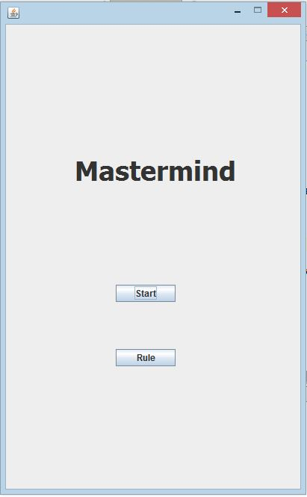

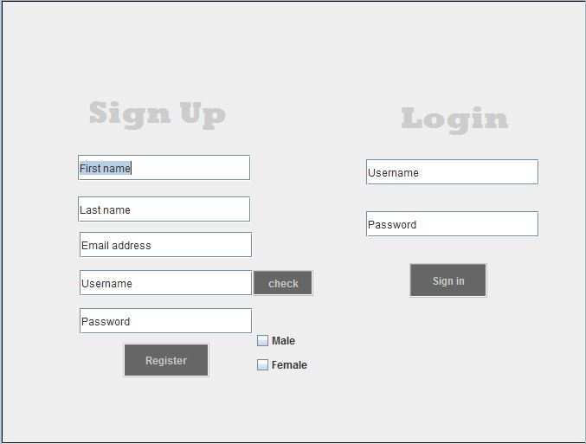**After Start, Login/ Register panel**

Has RegExCheck in each text field. After focus lost, the background of the text field turn green if valid, red if invalid.

Check button checks the Username with database to make sure the username is unique. Register button add the data to the database.

After press sign in and check with database, the prog will try to load the previous game if there is any. Otherwise, it will make a new game.

**Game Panel**

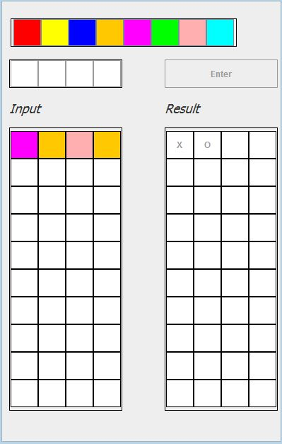Colors are buttons.

4 boxes above input is player current input. after 4 boxes are filled with color, enter button enable.

After enter button is clicked, it shows the result, X and O. X means correct place, and O means correct digit.

It will auto save every time the player presses enter.